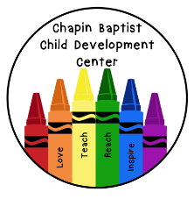
4’s Daily Schedule
7:00-8:00 Arrival, Child guided play, Centers
8:00-8:30 Transition, Clean up, Restroom, Wash hands
8:30-9:00 Teacher guided lessons, Songs, Finger plays, Morning activities
9:00-9:30 Snack, Clean up
9:30-10:00 Activity (Art, Bible, Science, Music, etc)
10:00-10:15 Transition, Clean up, Restroom, Wash hands
10:15-10:45 Outside (weather permitting) or Recreation Room, Gross motor play
10:45-11:00 Transition, Restroom, Wash hands
11:00-11:30 Lunch, Clean up
11:30-11:45 Quiet activity (Books, Puzzles, etc.)
11:45-12:00 Transition, Clean up, Restroom, Wash hands
12:00-2:00 Rest/Nap time
2:00-2:30 Transition, Restroom, Wash hands
2:30-3:00 Snack, Clean Up
3:00-3:15 Transition, Restroom, Wash hands
3:15-4:00 Outside (weather permitting) or Recreation Room, Gross Motor Play
4:00-4:30 Transition, Restroom, Wash hands, Afternoon Cleaning
4:30-5:00 Child guided play, Centers
5:00-6:00 Continued child guided play, Final departures

