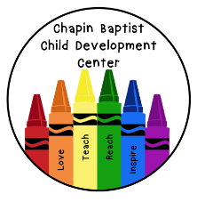

Infants

Our strict safety policies and our caring teachers make our infant program a safe and nurturing place for infants to be. A baby’s favorite “toy” is the human face. That’s one of many reasons why interaction with teachers is our primary focus. We believe literacy starts with the “conversation” that consists of an infant’s fussy cry and a caregiver’s responsive action to feed a bottle or change a diaper.

Individualized Care
Our infants follow their own personal schedule. There is no group time for lunch or nap. Instead, we follow the ever-changing meal and sleep patterns of each infant.

Infant Activities
Since routines are a big part of an infant’s schedule, we incorporate many learning activities into this structure. Diaper changes and feeding times are a natural place for face-to-face “conversations” between teacher and child. Nap time is a great time for singing soft songs and rocking them to sleep. In addition to routines, there are activity areas for crawling and cruising, and areas with lots of toys and books to foster infant development. Our Bye-Bye Buggy makes it possible for our infants (when able to sit up) to go outside in good weather for a stroll. Infants also enjoy time on the playground each day (weather permitting). Our teachers spend a lot of time singing songs and reading books with the children.

